# DECLARATION

I, Edwin ngila kyalo of AdmNo. 230192, certify that this project is my own work, based on my personal study and research done. I acknowledge all the resources and materials used to come up with this project whether it was articles, class notes, reports, and any other kind of documentation.

I also certify and confirm that this project has never been submitted anywhere for academic audit and that it has not been copied in whole from any source or otherwise plagiarized from any source or persons.

I confirm that I have identified and declared all possible conflicts that I may have.

Signed and confirmed by: -

Candidate Name:

Candidate signature:

Date signed:

Supervisors Name:

Supervisors Signature:

Date signed:

# ABSTRACT

A stock management system, is a system that is used to make the work of entrepreneurs especially in the storage space easier. There are many types of stock manegment system but the documentation is focused on one method which is Perpetual inventory management system. By compering to current works that are available in the market and identifying the gaps that the works have and trying to solve them through the current system in development. The methodology that is been used during the development of this system and during the writing of the project documentation is Agile methodology. Agile is considered to be the best methodology that is currently in use. The main out put that is expected from the end of the project is to have a system that will reduce the time taken during stock taking, have a system that is going to track items in the supply chain, give feedback and reports to the user after a duration of time, connect branches to the warehouse for easy communication, help the warehouse in stock optimization and help stock takers keep track of dates of goods in the storage unit. The impact of using the system in the day to day activates of the business is efficiency.

# LIST OF FIGURES

Figure 1time taken 4

Figure 2 distribution cycle 6

Figure 3showing the agile flow 10

Figure 4 showing the key for the flow chart 14

Figure 5 requirement in modeling 14

Figure 6 flow chart 1 16

Figure 7 flow chart 2 17

Figure 8 flow chart 3 18

Figure 9 flow chart 4 19

# LIST OF TABLES

Table 1functional and non-functional requirements 13

Table of Contents

DECLARATION i

ABSTRACT ii

LIST OF FIGURES iii

LIST OF TABLES iii

1 CHAPTER ONE 1

1.1 introduction 1

1.2 background of the study 1

1.3 problem statement 2

1.4 objectives 3

1.5 Scope of the study 3

1.6 justification 3

1.7 budget and resources 3

1.8 project schedule 4

2 CHAPTER TWO 5

2.1 literature review 5

2.1.1 Introduction 5

2.1.2 Time taken during inventory management 5

2.1.3 The number of people employed in the warehouse 5

2.1.4 Changing demands in the market place 5

2.1.5 Expiration dates 5

2.1.6 Lose of data 6

2.2 Description and representation of the system 6

2.3 Analysis of SIMILAR WORKING systems 7

2.3.1 Monday.com 7

2.3.2 Sorty 7

2.3.3 Ship Bob 7

2.3.4 How to solve the current existing gap? 8

2.3.5 Pros and cons of the system 9

3 CHAPTER THREE 10

3.1 project methodology 10

3.1.1 introduction 10

3.1.2 Representation of the methodology 10

3.1.3 Advantages of using Agile 12

3.1.4 Disadvantages of using Agile 12

4 CHAPTER FOUR 13

4.1 SYSTEM ANALYSIS AND REQUIREMENT MODELING 13

4.1.1 Introduction 13

4.1.2 Functional and non-functional requirements 13

4.1.3 Flow of data in the system 14

4.1.4 Flow chart key 14

4.1.5 WAREHOUSE FLOW CHARTS 16

4.1.6 BRANCH FLOW CHART 19

5 CHAPTER FIVE 20

5.1 SYSTEM DESIGN 20

6 CHAPTER SIX 21

6.1 SYSTEM IMPLEMENTETION 21

7 CHAPTER SEVEN 22

7.1 LIMITATION AND RECOMMENDATIONS 22

REFERENCES 23

APPENDIX 25

# CHAPTER ONE

## introduction

what is a stock management system? A stock management system or also known as an Inventory management system is used to maintain an optimal stock level (make sure that the level of items is consistent), track goods during transit, receive new items, manage warehouse processes such as packing and distributing, preventing items from becoming outdated and prevent spoilage, and ensure your products are never out of stock.

## background of the study

The project come to my attention during an exaction to a supermarket warehouse. In this warehouse their where people walking around counting items that where in stock and noting them down in their notebooks and after the counting is done, they would tally the total and make decision based on the outcome.

This process takes them 3 to 4 hours after closing hours, and it is done four times a week, even after the process the outcome of the result is still not accurate as it should be. After research the outcome shows that it is advisable to carry out the process once every month, but this is only achievable if the organization has a fully working system in the works.

Diving in deeper to the manegment portion of the warehouse the manager complained that the number of employees that are used to take the stock is a lot and is monetary expensive to them. This problem is not faced only by them but many of the warehouses are all facing the same problem.

The warehouse also does not give an accurate estimate of the net income that it brings in because of loss of manually written recipes. Many of the supplies that bring in items operate through manually written recipes. The warehouse also has a challenge of keeping up with orders given to them by the branches of the supermarket.

Another thing is, it is hard for them to keep track of goods that are nearly or in the verge of getting expired so as to remove them from store and make space for new items to be restocked

## problem statement

The problems that stock takers came by during the operation are; over stocking as a result of under counting, items getting lost in the warehouse, the cost of items is undervalued, data lose through loss of tally sheets and supplier receipts, warehouse revenue (the amount of money that a warehouse brings in in the end of the year), keeping track of items that have or almost about to expire and keep up with branch demands.

To solve the problems that have been identified we need to know the types of systems that are used. Examples of stock management systems are: -

1. Manual inventory management system. (pen, paper and counting)
2. Periodic inventory management system. (manual system integrated with perpetual system)
3. Perpetual inventory management system. (a fully automated)

For the purpose of a well efficient, self-running system the perpetual inventory management system is the best route to take for the problem at hand. A Perpetual inventory management system is a system that is fully automated. The system checks for the levels of stock of items, tracks transactions, updating cost of items at every stage of the cycle, it also tracks sells and updates in real time.

Over stocking as a problem can be solved through the process of keeping track of items that are fast moving and items that are not fast moving. When this is taken to consideration the warehouse is able to know the items that should never run out and also know the items that should not be considered during re-stoking. The system will keep the recodes of the items in the stock and every time there is a perches the system will minus and at the end of the day show the summary of the day.

Items getting lost in the warehouse can be solved through checking in items when the suppliers bring them in. at the same time when the items are being checked in the warehouse the suppliers with manual receipts will be captured through a picture and stored for future references. During the checking in the uses is required also to enter the buying cost of the items. The system will reduce the time used for check-in by using a barcode reader that will be used to scan the bar code of the boxes for easy input and will also solve the problem of track. Tracking in the warehouse is used to follow the items from the supply end till the item is on the shelf.

A warehouse is usually a central place where goods are stored and later distributed to the branches. The system will have a messaging or an alert portal that will be able to receive alerts from the branch managers requesting items that are depleted from their holding house or giving the reports back to the warehouse manager telling him/ her that the goods have been received. The system will have two

## objectives

The objectives from the problems stated are: - have a system that will receive input through the use of barcodes and manually, have a system that will track items in the warehouse, have a system that will keep recodes e.g. Supplier receipts and supply branch recodes, have a system that tracks the fast-moving items and gives the times that the fast-moving items occur, have a system that will extensively show summaries of the total distribution in a month and at the end of the year which will ensure that the business meets its targets, have a system that will help in tallying items using barcodes and have a system that will contact the suppliers to restock. The system will be divided into two one part for the warehouse and one part for the branches.

## Scope of the study

The project will cover mostly on the basis of supermarket warehouses. The goal of the project is to help supermarket warehouses to keep track of goods from the time the products come from the suppliers to the storage to the end consumers. During the process a lot of activities take place and it is hard to keep up with every step from dealing with multiple suppliers, accounting for every item in the warehouse and keeping up with branch demands.

## justification

The project at hand will bring a big change to the supermarket warehouse management at large by; reducing the number of workers needed in the warehouse end of the business, budgeting for a re-stocking, avoiding human error, saving time, and improving accuracy. The project will save the organization monetary revenue when considered.

## budget and resources

to come up with the project the budget and resources to be considered is: - a well working laptop, a code editor, internet connectivity, class notes for reference and server space for web hosting.

## project schedule

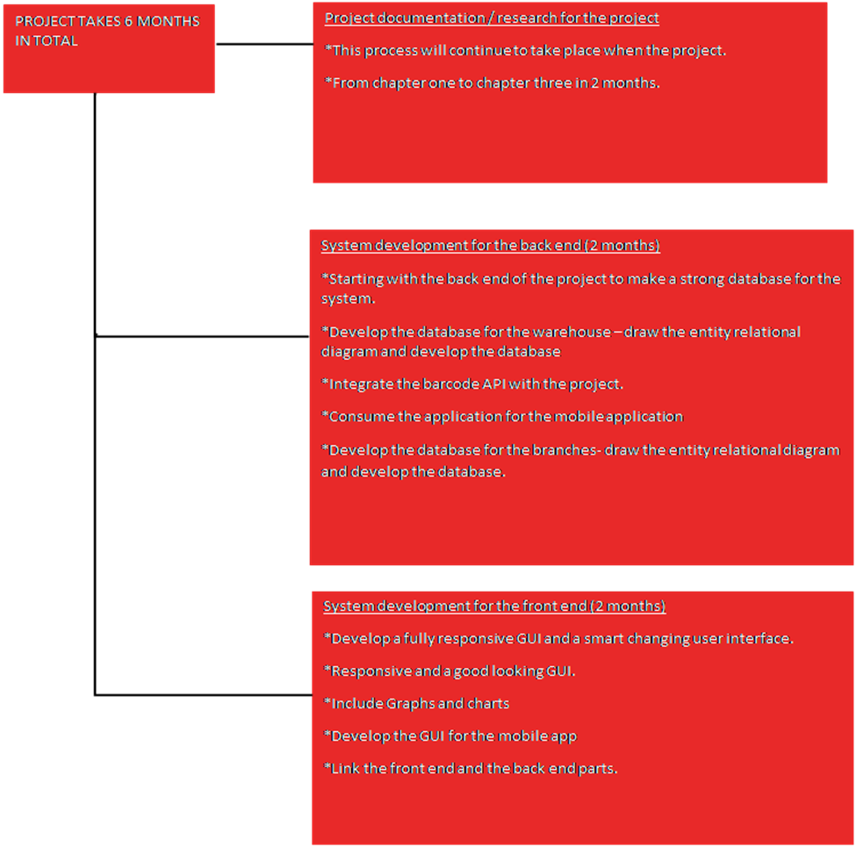

Figure time taken

|  |
| --- |
|  |
|  |  |

# CHAPTER TWO

## literature review

### Introduction

In the literature review, we will be able to show studies of the current working system and show studies that relate to the development of the system and challenges that the old system had.

### Time taken during inventory management

The Manual inventory management system is time-consuming for the workers in the warehouse sector of the business. According to skuvault.com, it takes 3-2 weeks to conduct a full physical stock count and in the process, not all the items are counted. But it is not the same case when using a Perpetual inventory management system. From an anecdotal view, I think when using the system, it will not take the longest time to carry out the process. In addition, the system will be automated and give up-to-date details of items in stock.

### The number of people employed in the warehouse

The number of people needed during the stock-taking process will be determined by the size and capacity of the warehouse according to unleashedsoftware.com. The system that is currently in development uses a barcode reader which makes it easier even for one person to carry out the stock-taking process.

### Changing demands in the market place

The consumers of the products are going to determine the number of items that should be available and ready to be distributed to the deferent branches. According to netsuite.com the manual inventory management system does not keep up with customer demands, compared to Perpetual inventory management system which is automated it will keep up with the customer demands by giving alerts to the user indicating that the levels of items are about to end. Also by going off customer demands we will avoid overstocking warehouses

### Expiration dates

It is hard for organizations that use manual inventory management systems to keep track of the items that are almost or about to expire. For the Perpetual inventory management system there are measures that have been put in place to avoid keeping items from spoiling in the warehouse where determine the shelf life of an item is determined by: -

SHALF LIFE

CURENT DATE

=

EXPIRATION DATE OF ITEMS

-

### Lose of data

Data that is collected through ether data tally sheets or supplier receipts can get lost. To avoid this, the new system will capture the manual receipts and store them for future reference.

## Description and representation of the system

The system process can be illustrated through a diagram: -

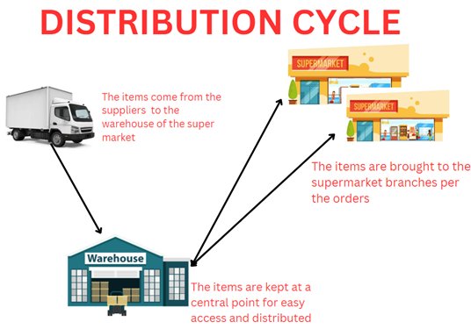

Figure distribution cycle

The warehouse gets items from the suppliers and stores them in order to distribute them to other branches. For a small description of the process: - The items are brought into the warehouse and during the process, the boxes are scanned to get the names and the product information which is stored in the database, the items are then kept in the warehouse. The branches also have access to the system where if an item ends up in the store, the store manager can scan the barcode and send the request to the warehouse and the item will be packed and sent to the branch.

## Analysis of SIMILAR WORKING systems

In the current market today there are many types of inventory management systems but I have managed to identify three similar stock management systems that are almost similar to the current project in development.

### Monday.com

This is a system that uses tools that allow it to be used as an inventory management system. The system lets the users categorize each item, add descriptions, add items in categories, and status of each item. The downside of the system is that it does not automatically monitor your inventory and notify you when items get depleted in stock.

### Sorty

It is a web-based inventory management system that caters to the needs of small-scale businesses. The system has an in-build QR code and bar-code readers that is used for inventory tracking, activity reports, and status reports. The system has an inbuilt notification system that is used to alert the users when an item is about to deplete, it also has an option of seeding emails to the users as another method of notification. It is also available in play store and IOS users. The down side of this system is that it is not able to give notifications to the users based on the shelf life of item and the cost of a subscription for the service at every month is 25$ dollars which is equivalent to 3,437.98 ksh which might be costly for businesses.

### Ship Bob

This is a popular choice for most wholesalers, retailers, and e-commerce businesses. It is designed to help enhance the delivery time, shipping cost, and overall shipping experience to the customers. This software can be combined with other e-commerce platforms. The problem with the system is that it only targets a specific demographic of people, where it links the warehouse direct to the people who place the orders missing the fact that it is not taking into consideration supplying to the retailers.

### How to solve the current existing gap?

The stock pilot is different from the current systems because the demographic of people that the stock pilot system is targeting is on the basis of items from the suppliers to the warehouse to the retail shops. In-depth, when the items are received from the suppliers they are entered into the system through the use of a special barcode scanner that gets information from the product boxes and keeps it in a database that relates to the Sorty system. When items are checked into the warehouse there is a counter that keeps track of the shelf life of each item and when items expired or are about to expire the user will receive a notification that the item is about to go bad. When items from the bunches are about to deplete the store manager is tasked to scan the barcode of the items and enter the amount that will accommodate the branch. In addition, the system itself will know the quantity of the item to send to the branch based on the user’s consumption rate. When checking out items from the warehouse the warehouse manager will be required to scan the barcode and enter the quantity of items to send to the branches and the system will minis the item from the system. At the end of the day the system will generate daily reports that will be shown to the warehouse manager and at the end of the month it will sum up the monthly reports and show which items that are in high demand. This will also show which items that should be prioritized during re-stocking.in addition, the system will allow the user to customize notifications to send an alert telling them that it is time to make an in house stock take.

### Pros and cons of the system

#### Pros of the system

The system will bring benefits to the business like: -

1. All the documentations e.g. supplier’s recipes are kept digitally.
2. There is no need to take stock because the items will automatically show the items in stock.
3. The number of employees that are needed will reduce due to the automation of the system.
4. Alerts users when items are about to run out.
5. Space optimization.
6. Goods prioritization.
7. Consistency of goods supply to branches.

#### Cons of the system

The system also has a down side to it: -

1. The system is not able to secure the user from any physical theft.
2. The system is prone to attacks when system checks are not frequently done.
3. The system in not countable for physical spoilage of goods.
4. Scanning errors.
5. Some products might not have a barcode scanner so manual input is needed.

# CHAPTER THREE

## project methodology

### introduction

Project methodology is where the development process and steps that have been taken to develop the system is taken into consideration. Their many ways that one can use to systematically come up with the system, and out of the many types of project methodologies e.g. Agile, Waterfall, Scram etc. For the purpose of this system, Agile model is the best way to go.

Agile- this is a methodology where the project is broken down into sections known as sprints and distributed to various developers and it a good methodology when working with many developers. This methodology focuses heavily on the customer needs and the software part of the system and less on the documentation.

### Representation of the methodology

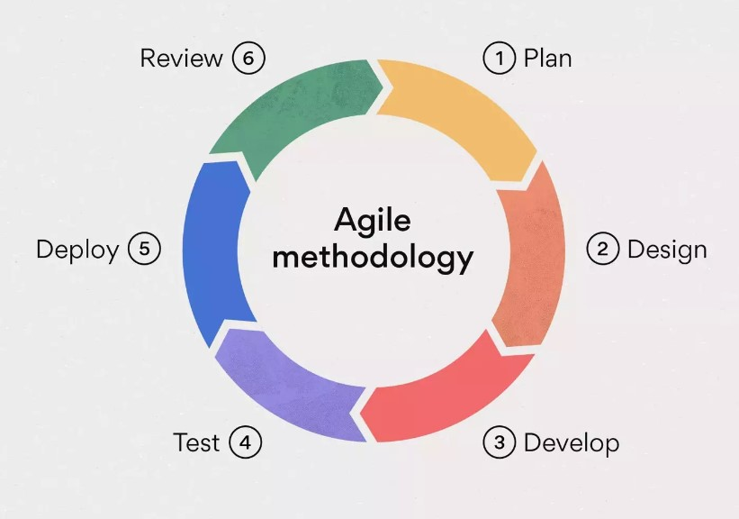

Figure 3showing the agile flow

#### Planning

In this sage the project manager is needed to speaks to the customer and know the customer requirements. The manager is also tasked to review the initial working system and come up with a documentation that is going to guide the developers during the development stage of the Agile life circle. At this stage the project manager is needed to come up with a project schedule showing the time that it will take to came up with the end product. The project manager is given the task of identifying both the front end and back end team and briefing them.

#### Design

In this stage the team is tasked to review the documentation given by the project manager which has the requirements given by the customer and design the system around the requirements. In this stage the developers also come up with sketches for the system.

#### Develop

In this stage the project manager is tasked on selecting a team of front end and back end developers which are then divided up into scrum teams in both sides, in the front side and the back side. Then the project manager then gives each scrum team a sprint to work on and each sprint is given a date to which the work should be submitted.

#### Test

After the development stage the system is presented as a beater version and given to the testing team and the team takes the system through harsh conditions in order to know the holes the system has, so as they can patch up the system and test the system.

#### Deploy

In this stage the system is presented to the customer and some members of the development team is tasked to educate the customer on how to use the system and desensitize them from the initial system. At this point the developers also help the customers to migrate to the new system.

#### Review

Because the Agile methodology is more flexible the review stage is open at all times during the development process of the system, which means that in this stage the customer has the ability to

him in ideas at any time and also after the project has been delivered to them. This stage is also when the developer also updates the system per the user requirements.

### Advantages of using Agile

The advantages of using Agile methodology are: -

1. Agile is more flexible it can start from any point of the software life cycle.
2. Fast time delivery to the market due to the distribution of tasks.
3. Delivering of a quality product to the customer.
4. There is a risk redaction.
5. Competition among developers of the company.
6. Higher customer satisfaction because the customer is involved in the development process.
7. Continues delivery and continues improvements to the system.

### Disadvantages of using Agile

The disadvantages of using Agile methodology are: -

1. It is less predictable.
2. More time and commitment is needed.
3. It is demanding for both the customers and developers.
4. The system entropy is likely to affect a system developed through the methodology.
5. Little or no documentation of the end product because the system methodology focuses highly on customer satisfaction.

# CHAPTER FOUR

## SYSTEM ANALYSIS AND REQUIREMENT MODELING

### Introduction

In this stage the developer is needed to illustrate how the system operates and show the problems that came with the system. The developer is also tasked to come up with a data flow chart that illustrates on how the system works.

### Functional and non-functional requirements

|  |  |
| --- | --- |
| FUNCTIONAL REQUIREMENTS | NON-FUNCTIONAL REQUIREMENTS |
| Product input | Using barcode scanners. |
| Taking stock time | Implementation of barcode scanners. |
| Expiration date | Giving system alerts to the user when the counter date is less than a given date. |
| Sending list of items to restock | Branches giving notification of items needed to re-stock. |
| Watching stock limits | Give a notifications when a products are about to end. |
| Summaries | Giving compressive documentations about daily, monthly and yearly stock in-takes and deliveries. |
| Fast moving items | Counting the amounts of goods that are high in demand |

Table functional and non-functional requirements

### Flow of data in the system

Showing the data flow from the log in point of the system and in addition showing the system branch and operations.

### Flow chart key

Showing the start and stop of the system.

Showing the flow of data from the starting point to the end point.

Showing the process point of the system.

Decision making point of the system.

Figure 4 showing the key for the flow chart

Figure requirement in modeling

Showing the input or the output of the system.

Showing the database of the system.

Showing the manual input point of the system.

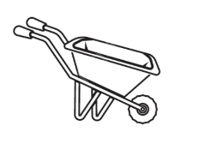

Showing goods been transport.

Figure 5 requirements in modeling

### WAREHOUSE FLOW CHARTS

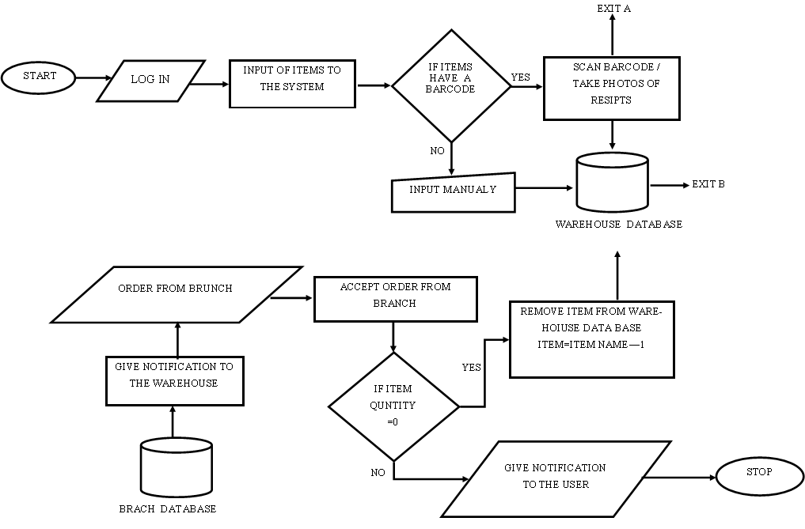

Figure flow chart 1

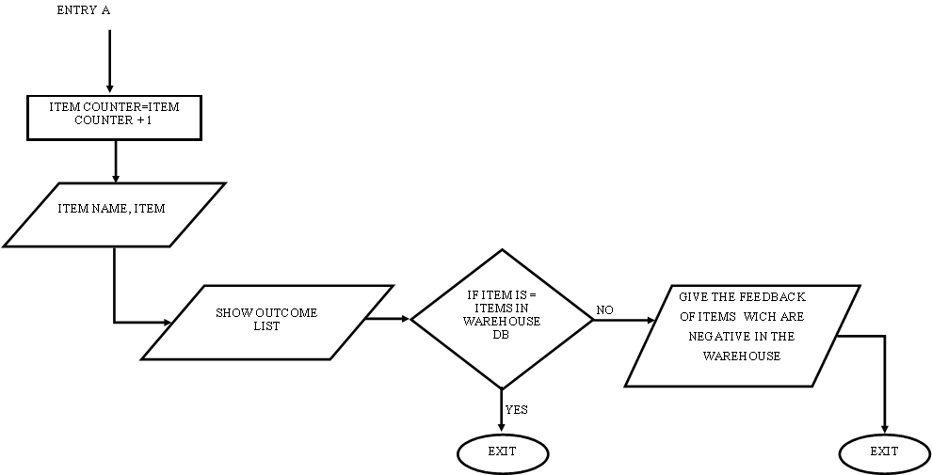

Figure flow chart 2

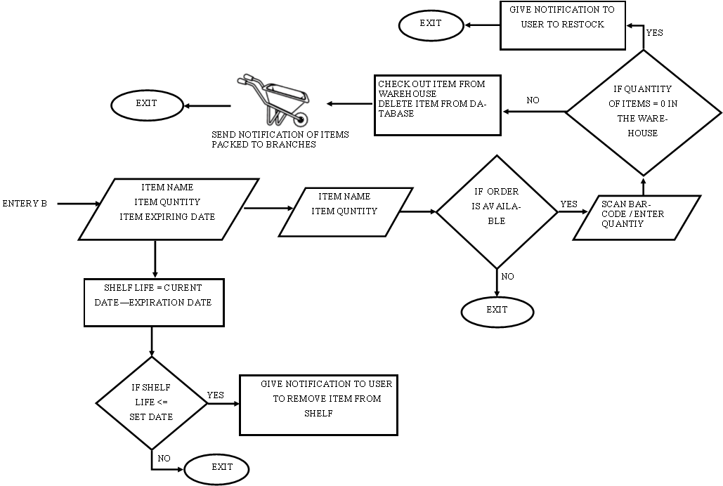

Figure flow chart 3

### BRANCH FLOW CHART

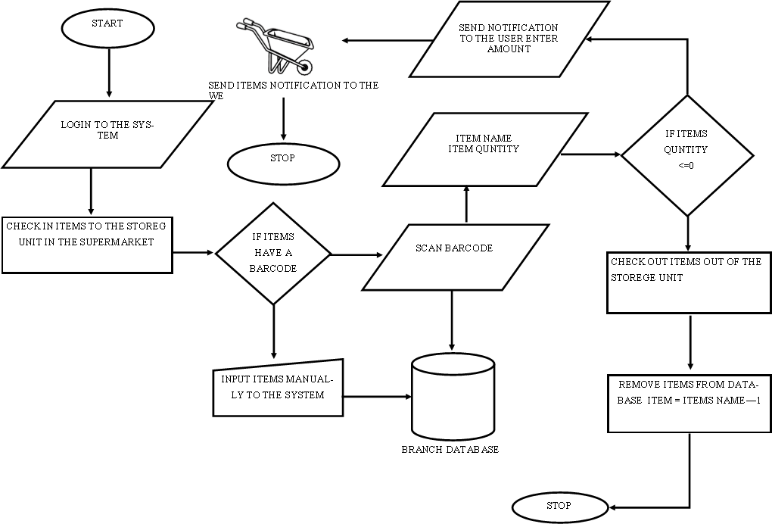

Figure flow chart 4

# CHAPTER FIVE

## SYSTEM DESIGN

### Introduction

In this chapter we will cover the database side of the project and figures that illustrate how the database works with Entity relational diagrams (ERD) to show them. Which will show how the tables will relate to each other and all the columns needed and the key fields.

# CHAPTER SIX

## SYSTEM IMPLEMENTETION

# CHAPTER SEVEN

## LIMITATION AND RECOMMENDATIONS

# REFERENCES

Tally solutions (2023, March 20th). *What are the Different Types of Inventory Management Systems?* Tally Solutions <https://tallysolutions.com/inventory/types-of-inventory-management-systems/>

Anindita.K (2018, May 23rd). *The Importance of Stocktaking for Retail & Wholesale Businesses and what is stock manegment* Medium <https://kanyaanindita.medium.com/the-importance-of-stocktaking-for-retail-wholesale-businesses-fc1cfc23d1ff>

DynamSoft (DAS 2023, June 13th). *JavaScript API Reference* <https://www.dynamsoft.com/barcode-reader/docs/web/programming/javascript/api-reference/>

Avery. W (2023, June 06th). *Taking a Physical Count of Your Inventory - What You Need to Know* SkuVault <https://www.skuvault.com/blog/taking-a-physical-count-of-your-inventory/#:~:text=This%20creates%20an%20equilibrium%20for,a%20complete%20physical%20inventory%20count>

Unleashed Software (2023, May 12th). *Stocktaking* <https://www.unleashedsoftware.com/inventory-management-guide/stocktaking>

Calculator Academy (2022, September 20th). *Shelf Life Calculator* <https://calculator.academy/shelf-life-calculator/#:~:text=To%20calculate%20Shelf%20Life%2C%20subtract,and%20the%20date%20of%20manufacture>

Epstein. D (2023, May 24th). *10 Best Inventory Management Systems for 2023* Financesonline.com <https://financesonline.com/top-10-inventory-management-software-systems/>

Laoyan.S (2022, October 15th). *What is agile methodology? (a beginner's guide) [2023] • asana*

Asana <https://asana.com/resources/agile-methodology>

Paterska.P (2021, October 01st). *10 Most Important Benefits of Agile Methodology* <https://www.elpassion.com/blog/10-benefits-of-agile>

# APPENDIX